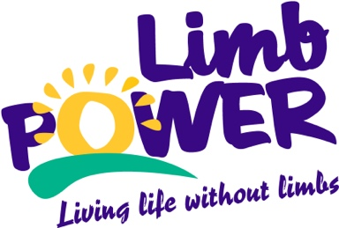
LimbPower
Equality and Diversity Statement

Diversity and Equality Statement
. LimbPower will continue to promote diversity and social inclusion as part of our governance strategy. We will continue to build a culture of diversity and inclusion across all areas of the organisation, including appointments of board members, staff, volunteers, membership and participants.
LimbPower recognise that equality in sport has not yet been achieved and is something that ourselves and our partners strive towards through our internal policies and programmes.
LimbPower believes that ‘everyone is equal’ and should have access to the same opportunities irrespective of their personal characteristics. This includes promoting equality and diversity for all people, but in particular for those identified by the equalities act (2010);
- Disability
- Sex
- Age
- Race
- Gender reassignment
- Religion or belief
- Sexual orientation
- Marriage or civil partnership
- Pregnancy and maternity
The aim of the policy is to ensure no job applicant, employee or volunteer is discriminated against either directly or indirectly on the grounds of race, colour, ethnic or national origin, religion, belief, sex, marital status, sexual orientation, gender reassignment, age or disability.
LimbPower welcome input from staff, volunteers and community members on how we can reach diverse and hard to reach communities.
This policy statement applies to all trustees, staff, volunteers and service users.

